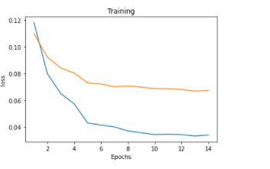

[1, 3500] loss: 0.11830

Avergae_validation_loss was=0.10988011123239994

[2, 3500] loss: 0.07994

Avergae_validation_loss was=0.09225275213023026

[3, 3500] loss: 0.06505

Avergae_validation_loss was=0.08417950400710106

[4, 3500] loss: 0.05736

Avergae_validation_loss was=0.08035687310993671

[5, 3500] loss: 0.05736

Avergae_validation_loss was=0.07304298892989755

[6, 3500] loss: 0.04154

Avergae_validation_loss was=0.07216355851416786

[7, 3500] loss: 0.04014

Avergae_validation_loss was=0.07017663654188315

[8, 3500] loss: 0.03712

Avergae_validation_loss was=0.07070758423581719

[9, 3500] loss: 0.03577

Avergae_validation_loss was=0.06985911010950804

[10, 3500] loss: 0.03436

Avergae_validation_loss was=0.06874641467009981

[11, 3500] loss: 0.03472

Avergae_validation_loss was=0.06862434934079648

[12, 3500] loss: 0.03434

Avergae_validation_loss was=0.06817571768537163

[13, 3500] loss: 0.03335

Avergae_validation_loss was=0.06680934913704793

[14, 3500] loss: 0.03412

Avergae_validation_loss was=0.06736660042777658